April 17, 2015
Warm-up Activity: Interviewing strangers
- Spoke to Miyu and Rina, two freshmen from Obirin, during the Fuchinobe International House’s welcome party
- They approached me initially (they wanted a photo together)
- Discussed learning foreign languages (they’re currently studying English and have expressed interest in studying abroad)
- They asked about my experiences at Obirin, as well as some more personal questions (very bold personalities…)
- Once they heard that I’m in an international relationship, they asked about long-distance situations and language barriers
- Also discussed driving, work, travel differences in U.S.A and Japan
April 29, 2015
Fieldwork #1
ITINERARY: Met at Machida station at 2:30pm, originally planned on going to the art museum found near Serigaya Park, but it was closed. We toured some local small businesses instead, and finished with our fieldwork by 5:50pm.
- April 29th was a national holiday, so Machida was full of a variety of people. Serigaya Park had many families with young children, and the shops closer to the station were busy with young (junior high, high school-age) students. All of the shop attendants appeared to be busy, so we weren’t able to ask them any questions.
- We didn’t know where we wanted to visit when we first gathered, Raz suggested Serigaya Park, and Lizet was already interested in interviewing local businesses. While we searched for ideas, Victoria came up with more research possibilities, and Kota gave suggestions within Machida and Sagamihara because he understands the area very well.
PLANS FOR NEXT FIELDWORK
a) Determine what businesses/attractions are available in the Machida area
b) Narrow down possible research topics, find locations relating to such topics

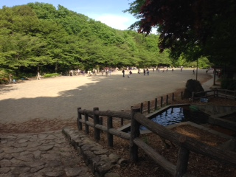

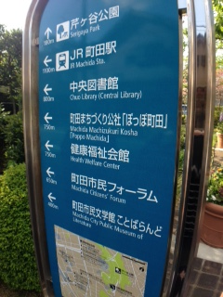
May 20, 2015
Fieldwork #2
ITINERARY: Met at Machida station at 2:30pm, visited a Catholic Church to conduct an interview. We also tried to get information from the Machida City Citizen Forum, but it was closed for the day. We finished our fieldwork by 5:30pm.
- Went to Catholic Church in Machida (Machida 3-2-1 Nakamachi, Machida-shi 194-0021 TOKYO)
  - 1600 attendees
  - Mostly converts (not from Catholic families)
  - 50% frequent attendees
  - Confession 2 or 3 times a week
  - Roman Catholic Church
  - 1 priest, bishop (no Cardinal)
  - Works with other nearby churches
  - Convent in Machida with 8 Vietnamese and 7 Japanese nuns
  - Saturday and Sunday school available
  - .04% Roman Catholic population in Japan (10% in Vietnam)
  - Church has 25 volunteer groups
- Attempted to visit Machida Civic Forum (International center, gender equality, etc.) but it was closed
  - While leaving, met a man who seemed knowledgeable of US customs and English education reform in Japan

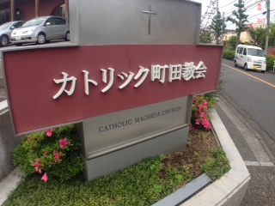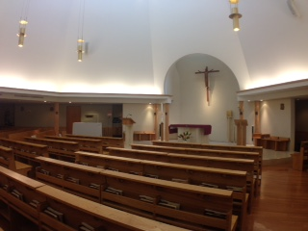
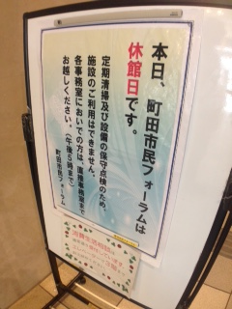
June 17, 2015
Fieldwork #3
- Interviewed Radhia at the Sagamihara International Lounge
  - She started working at the lounge in April 2015, in charge of English translation
    - Translations for health/law help
  - Organizes International Tea Party (up to 40 participants)
  - Japanese lessons available for foreign residents
  - Annual International Festival in October
  - Offers International marriage counseling (translator, neutral third-party)
  - Disaster prevention tours/drills for foreign residents and Japanese citizens
  - Advice for tourists (restaurants, gyms, etc)
  - Radhia started as a volunteer at the lounge 3-4 years ago
    - Foot-traffic has noticeably increased
  - Also works with NHK World translating English to Swahili
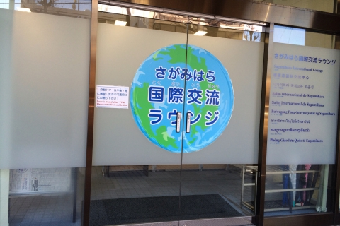
July 2, 2015
Fieldwork #4 (Tsuruya Kimono Shop)
Questions: What is the foreign clientele interested in/curious about? How have local businesses changed to accommodate foreign residents/tourists? Are there any possibly negative effects of accommodating to so many foreigners? Are there any changes to the international community that are unique to Sagamihara?
- Sagamihara was part of the Japanese Silk Road during the Meiji period, and became a US military hotspot in the 1940’s
  - “bad situation with good results”
- In anticipation of the 2010 Olympics, tourists stay in Fuchinobe (usually by accident) because Tokyo is too crowded
  - Experienced tourists decide to spend time in the area instead of typical tourist spots (Roppongi, Asakusa)
  - Foreigners enjoy having a local shopkeeper (Yasuharu-san) that can help them in English
- Sagamihara city has tried advertising in foreign languages, local businesses refer tourists to Yasuharu-san, try to express city mission/activities in English

July 21, 2015
Fieldwork #5
- Interviewed Takashi Okamoto from Sagamihara City Office, Foreign Affairs
- Majority of foreign residents in Sagamihara are international students, spouses in international marriages, employees of international companies
  - About 5% of the Sagamihara population
- Not too much tourist activity
  - Too many factories/offices to convey tourist image
  - Some potential (Mt. Takao)
  - Minor increases in tourism in the last 6 years
  - Potential for guides for upcoming Olympics (to uphold おもてなしtheme)
  - Not enough foot-traffic in museums from foreigners to add foreign-language references (to justify the cost)
- Aren’t enough foreign residents to really influence the Japanese residents
  - Around Aichi, there are more English language teachers, resulting in more major cultural differences that create issues (separating garbage, etc)
  - Non-Japanese mothers (of mixed-ethnic or nationalized children) can’t always understand school letters/announcements

Foreigners make up 1.5% of populace (The Japan Times, August 2013)
There were 1.98 million foreign residents in Japan as of March 31, accounting for 1.54 percent of the population, with 84.28 percent of them between the ages of 15 and 64, according to the latest government figures.
The data were released for the first time in the Internal Affairs and Communications Ministry’s regular Vital Statistics report, issued Wednesday. The basic resident register — the source for the data — started including non-Japanese residents who stay in the country for three months or longer last year.
The foreign population of 1,980,200 consisted of 894,719 males, or 45.18 percent, and 1,085,481 females, or 54.82 percent.
By age bracket, elderly people, defined as those 65 or older, constituted 6.77 percent of the total, compared with 24.4 percent for Japanese.
Those between 15 and 64, who play an important role in the workforce, comprised 84.28 percent, significantly higher than the 62.47 percent for Japanese.
The child population, up to 14 years old, was 8.96 percent, lower than 13.13 percent among Japanese.
A whopping 70.55 percent live in the three biggest metropolitan areas.
The Tokyo area, which includes Saitama, Chiba and Kanagawa prefectures, was home to 38.63 percent of the total, followed by the Kansai region of Kyoto, Osaka, Hyogo and Nara prefectures with 18.02 percent and the Nagoya region of Gifu, Aichi and Mie prefectures with 13.89 percent.
Among cities, central Tokyo’s 23 wards were home to 322,525 non-Japanese residents, followed by Osaka with 116,375. Yokohama ranked third with 74,713 and Nagoya was fourth with 63,892.
For towns and villages, Oizumi, Gunma Prefecture, had the largest presence, 5,913 people, who accounted for 14.53 percent of its overall population. The town is host to manufacturing plants that hire a large number of people with Japanese ancestry, chiefly from Brazil.
Children made up around 13 percent of the foreign populations of Gunma, Mie and Shizuoka prefectures. Many of them are believed to be offspring of foreign factory workers.

Is English a form of linguistic imperialism? (Anne Burns, April 2013, British Council)
In 1992 a book appeared in the field of applied linguistics that presented English language teachers with a highly challenging, even shocking, proposition. The author, Robert Phillipson, argued that the global teaching of English was an act of linguistic imperialism.
One of the major arguments in Linguistic Imperialism was that the spread of English, much of which had occurred through its prominence in global language education, has served to undermine the rights of other languages and to marginalise the opportunities that should exist for widespread multilingual education.
Since the 18th century, Phillipson argues, the spread of English has accompanied the political and economic intentions of English-speaking nations to conquer other countries. He claims this endangers their cultural ideals, their ways of life and their indigenous languages.
Collectively, English language teaching and its major agencies, such as the British Council, have been implicated in perpetuating myths about the significance and necessity of learning English and in ensuring that English has outstripped the teaching of other languages worldwide. Phillipson calls for radical change in language policy to redress the balance and to promote the multilingualism that reflects the more natural state of language use around the world.
Phillipson’s arguments have also provoked a number of criticisms, among which are making teachers feel unnecessarily guilty about teaching English, and adopting a patronising attitude towards developing countries by assuming they are incapable of making their own decisions about language choice. It has also been pointed out that a language of itself cannot be imperialistic.
Two decades on from when Phillipson’s book was published, we have another opportunity to debate his provocative questions about linguistic imperialism during this week’s IATEFL conference in Liverpool.
I am very much looking forward to facilitating the conversation among an expert panel of Dr Robert Phillipson himself, now Professor Emeritus at Copenhagen Business School; Dr Rebecca Kapitire Ndjoze-Ojo, former Deputy Minister for Education in Namibia; Dr Sarah Ogbay of the University of Asmara, Eritrea; and Danny Whitehead of the British Council in Indonesia.
The discussion is sure to provoke, challenge and stimulate, but what kinds of questions are likely to emerge? There are some that are still at the very centre of the debate: Are English language teachers promoters of linguistic imperialism? Or do they give learners access to a very important linguistic tool that helps individuals and economies to develop and compete globally? These questions continue to merit very serious consideration.
Moreover, as globalisation spreads and investment in English language learning increases, other questions continue to arise. Does the global spread of the English language threaten local languages, cultures and identities? Do these need to be safeguarded?
Japan and the West: The Meiji Restoration (1868-1912) (Asia for Educators, Columbia University)
- When the United States sends a naval delegation, led by Commodore Matthew Perry, to "open" Japanese ports in 1853, the Japanese are well aware of the "Unequal Treaties" that have been imposed upon China in the previous ten years (since the Opium War of 1839-42) as a result of the superior military power of the Western nations. The Japanese respond to the challenge of the West.
- Reform-minded samurai, reflecting the enormous changes that have taken place in the preceding Tokugawa period, effect political change. They launch the reform movement under the guise of restoring the emperor to power, thereby eliminating the power of the shogun, or military ruler, of the Tokugawa period. The emperor's reign name is Meiji; hence the title, "Meiji Restoration" of 1868.
- The Japanese carry out this modernization by very deliberate study, borrowing, and adaptation of Western political, military, technological, economic, and social forms — repeating a pattern of deliberate borrowing and adaptation seen previously in the classical period when Japan studied Chinese civilization (particularly in the 7th century to 8th century).
- Economic, political, and social changes that have taken place during the preceding 250 years of peace under the Tokugawa shogunate (1600-1868) lay the basis for the rapid transformation of Japan into a modern industrial power, with a constitution, a parliament, a national, compulsory education system, a modern army and navy, roads, trains, and telegraph — in less than 50 years.
- The emperor's effective power remains the same, but the reformers use the imperial symbol to rally public support and national sentiment for rapid modernization. In China, where a foreign power, the Manchus, holds imperial power from 1644-1911 (Qing dynasty), the similar use of imperial legitimacy — to mobilize popular support for social and political transformation to meet the challenge of the West — is not possible.
- Japan's successful transformation into a modern, military power is demonstrated first in 1894-95 and then in 1905-6. Japan defeats China, long the preeminent power in East Asia, in the Sino-Japanese War of 1894-5 over influence in the Korean peninsula. Japan defeats Russia, a major Western power, in the Russo-Japanese War of 1905-06 over rights in Manchuria and Korea. Chinese reformers and revolutionaries base themselves in Japan; Western nations take note of Japan's new power.
- Japan, which had isolated itself from international politics in the Tokugawa period (1600-1868), enters an international system of the late 1800s where imperialism dominates. Japan rapidly becomes a major participant in this international system and seeks particular imperialist privileges with its East Asian neighbors, China and Korea.
- By 1910, Japan annexes Korea as a colony and takes control over indigenous Korean modernization efforts. In 1931, Japan takes control of Manchuria and establishes the puppet state of "Manchukuo"; in 1937, Japan invades the rest of China.
- Japan's democratic political system continues to evolve under the Meiji constitution, but then is unable to meet the dual challenges of economic depression and the political power of the Japanese military leaders in the 1920s and 1930s.

